

**Background**

Short Breaks allow families of disabled children to take a break from their caring responsibilities whilst being reassured that their child is safe and enjoying new and positive experiences.

In addition to giving families a much-needed rest, the break also allows children and young people to take part in family or community-based activities, make new friends, gain independence and broaden their horizons. There are services available to support all children and young people with complex needs in Doncaster. This is known as the ‘Local Offer’. To access the Local Offer, families do not need to have an assessment, but must be registered with [Together Information Exchange (TIE)](https://www.doncaster.gov.uk/services/schools/together-information-exchange), which is Doncaster’s voluntary register of children and young people with a disability.

The main aim of the Short Break Capital Grant is to support Doncaster based organisations procure SEND based equipment to enhance accessibility and participation for young people with additional needs or disabilities and support them attend fun and inclusive activity-based provisions within Doncaster, and to enhance our Short Break provision and the Local Offer.

**Funding information**

Please be aware that the maximum amount of funding available per group is **£5,000**. This is to maximise the number of events/groups we are able to support.

* The equipment must be purchased by **31st March 2025** (with receipts submitted)
* The equipment procured must have been utilised within your project and published on the Local Offer by **30th June 2025**
* A final evaluation will need to be returned by **21st July** which will evaluate the impact of the equipment on your provision and whether you were able to engage with more children with SEND.

**Application Details**

Each group/organisation can apply only once. Please complete the relevant sections below and return to the address provided below:

|  |
| --- |
| The deadline for applications to be submitted is: **5th February 2025**  (Please note **all** policies and procedures in the final checklist must also be submitted along with your application for it to be considered). |

**Eligibility**

It is important that you complete this initial checklist before starting to complete the Funding Application. By doing this you will determine whether you are eligible to apply for funding before you spend time completing the funding application.

This is a Capital Grant therefore only physical goods, items and equipment will be funded, small building works or fixed physical aid may be considered.

(This fund will not cover staffing costs, or any running cost related to the activity)

**You are eligible to apply if:**

* Your event(s) involve young people with SEND or are registered with Short Breaks and or TIE, Together information exchange.
* Your group / organisation has trained staff or volunteers to deliver SEND based activities, utilising the Capital funding.
* Your group has the relevant Public Liability Insurance, Premises Licence (Building Insurance) Fire Evacuation and Risk Assessment Documents to run the activity; these must be available for inspection (Event Safety Management).
* Young people will help with and influence the planning and running of the event(s)
* You are happy to fully complete a monitoring form at each event which utilises the equipment funded.
* You agree to the terms of the funding agreement should your application be successful.
* You/your group is fully constituted.
* Your event promotes accessibility for young people with additional needs.
* Your group if fully aware of and has read the Grant Funding Agreement.
* You agree to provide all monitoring information on completion of your event / sessions immediately along with all receipts and any other information we request.
* Already a Short Break provider who can offer an enhanced activity experience with evidence of increased attendance through the purchase of specialist equipment.
* Already an activity provider who is in the process of applying to become a Short Break provider through our Flexible Procurement System, where the Capital grant will support activity based sessions for young people with additional needs.
* Promote your activity session within the Local Offer.
* Will continue to maintain and utilise the equipment for future activities to support inclusivity for young people with additional needs.

**Failure to comply with this may result in all monies awarded having to be paid back in full.**

|  |  |
| --- | --- |
| **Application Checklist** | |
| **Are you** | **Yes/No** |
| An Individual |  |
| A Gambling Club |  |
| A Political Organisation |  |
| An organisation looking to fund activities outside the Doncaster Borough |  |
| *If you have answered “yes” to any of the above, your organisation is not eligible to apply for funding.* | |
| **Does your organisation** | **Yes/No** |
| Have its own bank account, requiring 2 unrelated people to authorise cheques and make withdrawals? |  |
| Have at least 2 members on its governing body or board of Directors |  |
| Have a safeguarding policy, DBS and related H&S documentation. |  |
| Is your application for equipment or works up to the Value of £5,000? |  |
| Will your project funding be spent before 31 March 2025? |  |
| Will you publish your activities on the Local Offer to promote your sessions before the 30th of June 2025? (The utilisation of equipment procured, and delivery of the project can continue after this point) |  |
| *If you have answered “no” to any of the above, your organisation is not eligible to apply for funding.* | |
| **Will your project fund** | **Yes/No** |
| Professional Fundraisers |  |
| Capital contingencies |  |
| Gifts & entertainment |  |
| Faith based activity, that can't demonstrate wider community benefits |  |
| Outstanding debts |  |
| Automatic continuation costs |  |
| Animal or plant activity, that can't demonstrate wider community benefits |  |
| Overseas travel costs |  |
| Retrospective action |  |
| Staffing costs |  |
| Revenue funding |  |
| *If you have answered “yes” to any of the above, your organisation is not eligible to apply for funding.* | |

|  |  |
| --- | --- |
| **About your Organisation** | |
| Name of organisation |  |
| Address |  |
| Postcode |  |
| Telephone number |  |
| Email Address |  |
| Website (link) |  |
| Charity Number (if applicable) |  |
| Company Number (if applicable) |  |
| VAT Registration Number (if applicable) |  |
| Number of people on Governing Body |  |

|  |  |
| --- | --- |
| **Contact Information for Application** | |
| Main contact for application |  |
| Name |  |
| Telephone |  |
| Email address |  |
| Position within organisation |  |

|  |  |
| --- | --- |
| **Does your organisation meet the following requirements?** | **Yes / No** |
| Do you have safeguarding policies and procedures in place appropriate to your organisations work and the project you are seeking funding for? Which are reviewed annually. Staff are appropriately trained in Safeguarding (at least one member to Level 3) |  |
| Undertake DBS checks and seek references for staff and volunteers working with children and young people. |  |
| Follow statutory or best practice guidance on appropriate ratios of staff or volunteers to children and young people. |  |
| Provide child protection and health and safety training or guidance for staff and volunteers. |  |

**Does any member of your governing body or board of directors have a relationship to/with a senior officer or elected member of the council?**

**Yes / No**

**If yes, please provide details below**

**Short Breaks Capital Grant Proposal**

**Total Amount Applying For: ___________________**

*Please answer each question thoroughly as they will be assessed*

**1 Please tell us about your organisation, what experience do you have working with SEND Children and Young People? *How do you target and engage with Children & Young People with SEND, and how will you do this? What do you currently deliver? Do you have examples?***

|  |
| --- |
|  |

**2 What benefit will your project have within the community and how will this benefit SEND young people? *Include how the equipment will enhance your current provision, increase participation and how you will maintain and use the equipment for future community benefit.***

|  |
| --- |
|  |

**3 Who have you consulted with during the development of your project and how have you consulted with them?  *Who did you speak to? Have you got feedback from young people / families on what would enhance your current provision?***

|  |
| --- |
|  |

**4 How will your organisation contribute towards the Choose Kindness agenda detailed below? *How does your provision tie into the statements below? Please provide examples.***

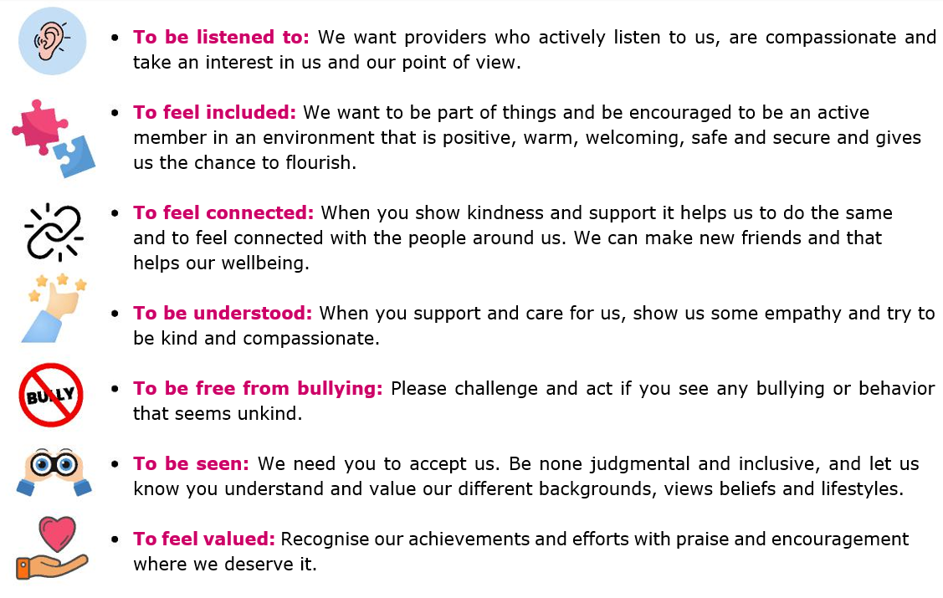

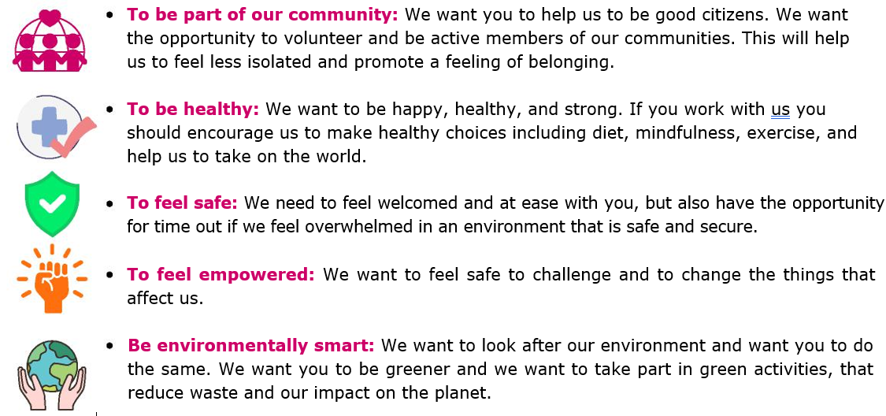

|  |
| --- |
|  |

**5 How will you try to ensure sustainability? Will you explore becoming a Short Break provider through Doncaster City Council Flexible Procurement System****?**

***How will you ensure the equipment is utilised beyond the initial grant period? There is support available for organisations to become a Doncaster Short Breaks preferred provider which will enhance the local SEND offer and will also help to ensure the sustainability of activities.***

[Flexible Procurement System for the Provision of Children's Short Breaks Services](https://uk.eu-supply.com/app/rfq/rwlentrance_s.asp?PID=70238&PP=ctm/Supplier/PublicTenders&B=UK&PS=1)

[Short Breaks - City of Doncaster Council](https://www.google.com/url?sa=t&rct=j&q=&esrc=s&source=web&cd=&cad=rja&uact=8&ved=2ahUKEwialOCIn96JAxWRU0EAHTwuOboQFnoECBUQAQ&url=https%3A%2F%2Fwww.doncaster.gov.uk%2Fservices%2Fschools%2Fshort-breaks&usg=AOvVaw0bPexBtrclvoQOQLLh9wV2&opi=89978449)

***Please note:******You do not need to become or be a Short Break provider to access this fund, although preferable.***

|  |
| --- |
|  |

**Developing the Local SEND Offer**

The Short Break Capital Grant is to support Doncaster based organisations procure SEND based equipment to enhance accessibility and participation for young people with additional needs or disabilities and support them to attend fun and inclusive activity-based provisions within Doncaster, to enhance our Short Break provision **and be added to the Local Offer Groups and Activities Page before the 30th June 2025.**

**9 Please use the spaces below to tell us about the events/sessions you will run that the equipment will be used for (example shown in red below). *This could be activities you currently run and new activities you plan to run with the equipment or works that support your session to become more inclusive.***

**These sessions must be open to all and published on the Local Offer.**

|  |  |  |  |  |  |  |  |  |  |  |  |
| --- | --- | --- | --- | --- | --- | --- | --- | --- | --- | --- | --- |
| **Start Date** | **Delivery Days** | **Total number of sessions delivered** | **Times** | | **Universal? (open to all)** | | **Delivery Address** | **Activity Name and Activity Details** | **Age range** | **Places available per session for SEND young people** | **Places available in total** |
| *1st April 2025* | *Every Tuesday* | *10* | *5pm* | | *Yes* | | *Cantley Community Centre* | *Targeted fun Camp*  *Arts and crafts*  *Multi sports* | *5-16* | *10* | 100 |
|  |  |  |  |  | |  | |  |  |  |  |
|  |  |  |  |  | |  | |  |  |  |  |

**Costings**

**6 Total Amount Applying For: ___________________**

**7 Please provide itemised costings that you are applying for funds for (Capital costs)**

|  |  |  |  |  |
| --- | --- | --- | --- | --- |
| Item Description | Item Cost | Amount Requested from us | Amount Secured from other funders (if applicable) | Total Cost |
|  |  |  |  |  |
|  |  |  |  |  |
|  |  |  |  |  |
|  |  |  |  |  |
|  |  |  |  |  |
|  |  |  |  |  |
|  |  |  |  |  |
|  |  |  |  |  |
|  |  |  |  |  |
|  |  |  |  |  |
|  |  |  |  |  |
|  |  |  |  |  |
| **Total requested** | | | |  |
| For any costs over £1,000 listed above please provide copies of quotations and/or links £1,000 below | | | | |
|  | | | | |

**Data Protection**

The information you are providing is being collected for the purpose of determining your grant application and will be passed on to the Grant Panel members in order to fulfil your request/ provide you with that service. Your information may also be shared with other relevant Departments within the council and other relevant partner agencies where the law allows. If you have any queries, please telephone 01302 735166 or write to Dean Mangham, Children’s Commissioning Lead, Civic Office, Waterdale, Doncaster, DN1 3BU or email [SBCapitalGrantFundApp@doncaster.gov.uk](mailto:SBCapitalGrantFundApp@doncaster.gov.uk)

[Short Breaks Privacy Notice - City of Doncaster Council](https://www.doncaster.gov.uk/services/the-council-democracy/short-breaks-privacy-notice)

**Freedom of Information Act**

The council is subject to the requirements of the Freedom of Information Act 2000. The information you provide may be requested. Applicants should be aware that requests for information under the Freedom of Information Act are considered individually and that we endeavour to liaise with any applicants regarding disclosure of information provided. Please note that the final decision as to whether the requested information will be disclosed lies solely with the council.

**Final Application Checklist**

Before submitting your Funding Application, please use this final checklist to ensure you have attached all the relevant documents that form part of your application. This will enable us to progress with your application without delay. **Please submit all documentation along with the application, Applications will not be considered without the accompanied documentation.**

|  |  |
| --- | --- |
| **Enclosed are** | **Please tick** |
| The organisation’s governing document e.g. constitution or Memorandum and articles of association, signed and dated, which include an appropriate dissolution clause. |  |
| A copy of your most recent accounts **(less than 1 year old)** which have been approved, or projection figures if you are a new organisation, which the grant will be paid into. |  |
| Copies of quotations / links for any items or works over £1,000 |  |
| Safeguarding Policies **reviewed and dated within the past year.** |  |
| Health & Safety Policy **reviewed and dated within the past year**, including Fire Evacuation where applicable. |  |
| Risk Assessments to run the activity |  |
| DBS for staff and Level 3 Safeguarding certificate for Designated Safeguarding Lead. Staff first aid certificates for those involved in delivery. |  |
| Public Liability Insurance Certificate **(£10m minimum)** |  |
| Your group has the relevant Premises Licence (Building Insurance) |  |

**Subsidy**

**Important. Please also complete the highlighted below regarding Subsidy requirements.**

**Recipient MFA Notification and Confirmation**

City of Doncaster Council (the “Council”) is proposing to offer [Please add your Organisations Name here XXXX ] (“You/Your”) a Minimal Financial Assistance (MFA) Subsidy under the Subsidy Control Act 2022, subject to Your agreement to, and compliance with, the terms and conditions set out below relating to the MFA which will be sent within the Grant Agreement if successful.

The amount of MFA proposed is [Please add your proposed grant fund request here taken from your total above £ XXXX ]. Before making the payment, the Council requires Your written confirmation that receipt of the payment will not exceed Your MFA threshold of £315,000 cumulated over this and the previous two financial years, as specified in section 36(1) of the Subsidy Control Act 2022.

This means You **must** confirm to the Council that You[1] have not received more than £315,000 in MFA subsidies or comparable types of subsidies[2], including this proposed MFA Subsidy over the elapsed part of the current financial year (i.e. from 1st April) and two financial years immediately preceding the current financial year.

***Please note:***

* ***The Council’s receipt of Your written confirmation is a legal requirement under the Subsidy Act 2022 and the Council is unable to award the MFA Subsidy without it.***

***If Your confirmation is subsequently discovered to be incorrect it could lead to You being legally required* Confirmation**

I confirm, for and on behalf of, [insert your Organisation name here xx] that receipt of MFA of [ amount of funds requested £x] from the Council will not exceed [insert your Organisation name here xx]’s MFA threshold specified in section 36(1) of the Subsidy Control Act 2022.

I confirm that:

* I have read and understood the Data Protection Declaration below and consent to usage of the information provided for the purposes described.
* I have enclosed all documentation along with the application, **Applications will not be considered without the accompanied documentation.**

Signed: _x______________________________________

Print name: _x____________________________________

Date: __x________________________________________

We take this opportunity to remind You that You are required to keep a written record of the amount of MFA You have received and the date/s when it was received. The written record must be kept for at least three years beginning with the date on which the MFA was given. This will enable You to respond to future requests from public authorities on how much MFA You have received and whether you have reached the cumulative threshold. If the Council is able to grant the proposed MFA Subsidy, it will issue you with an MFA Confirmation of Award to assist you with this requirement.

The Government maintains a publicly available [subsidy database](https://searchforuksubsidies.beis.gov.uk/). You should note that MFA subsidies above £100,000 are subject to legal transparency requirements. This applies per Subsidy award. This means that for every individual MFA Subsidy provided of more than £100,000, the Council must include details of the Subsidy on the national Subsidy Database.  Information on how this is used by the Government can be found on their [Privacy Notice](https://searchforuksubsidies.beis.gov.uk/privacy)

Data Protection Declaration

Personal details submitted on this form will be dealt with in line with Data Protection Legislation, this statement sets out what you need to know about how they will be used by Doncaster Council. Information provided by you will be used to process your subsidy. Your information may be shared with Government Departments, and agencies that prevent and detect fraud. These forms are retained for 7 years from date approved or from the date any subsidy has been processed.

More information on your rights and how Doncaster Council handles your information generally, can be found on the Council’s website.  You can contact the Council’s Data Protection Officer at [information.governance@doncaster.gov.uk](mailto:information.governance@doncaster.gov.uk) for more information.

**Declaration**

I confirm that I am authorised by my organisation to sign this declaration on behalf of the organisation. I also confirm that the organisation accepts the decision of the Funding Panel will be final.

1. Please note this includes any other companies/entities that are part of your group.
2. Please see section 42(8) of the Subsidy Control Act 2022